Experimentation, Elaboration & Exposition
“The Food GPS” Analogy – Experimentation Phase
Just as a navigation system guides a car from point A to point B, “The Food GPS” would guide surplus food from its point of origin (restaurants, supermarkets) to its best destination (families or community centers in need).
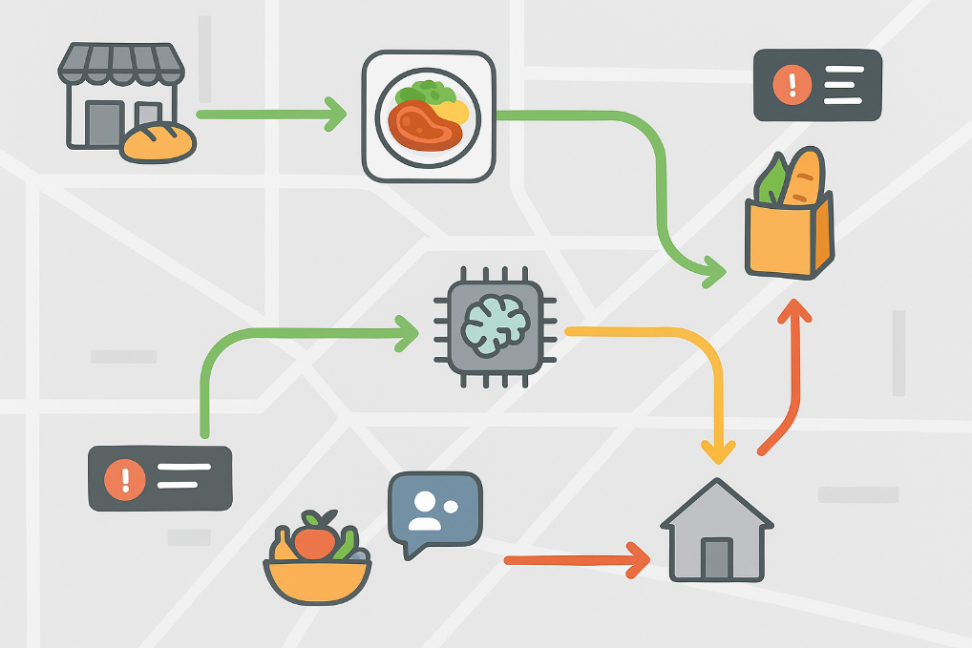
The map background represents the operational area; the food icons symbolize the available surplus (e.g., meals, fruits, or groceries). The routes are promptly color-coded: Green – fast and available routes; yellow – moderate delay or alert; red – urgent, risk of waste. Destinations: households, NGOs, or community hubs. The notifications and the AI symbol indicate real-time decision-making and route optimization.
Experience Storyboard: “The Food GPS” – Elaboration Phase
To move from the conceptual experience phase to the elaboration phase, a second prototype – the storyboard – was developed to illustrate the complete process.
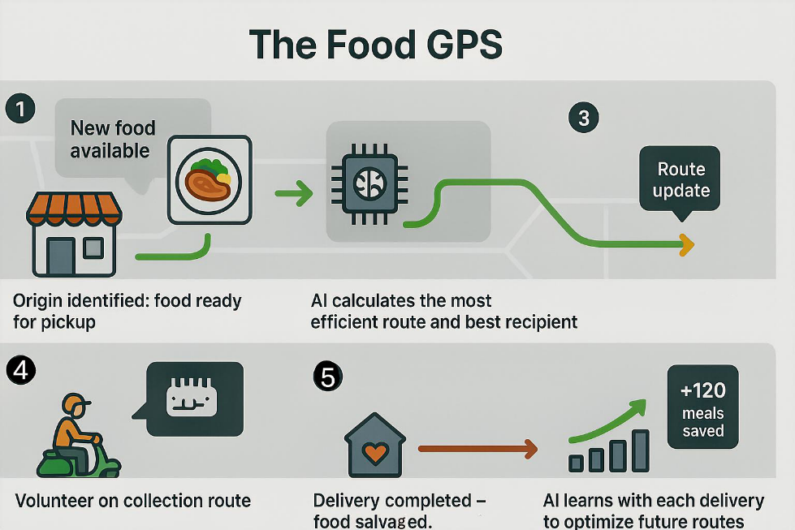
Food available: a restaurant or shop registers surplus food on the platform. Route calculation: the AI suggests the optimal route and best recipient based on proximity, availability, and urgency. Pick-up and notification: volunteers receive real-time alerts to collect and deliver the food. Delivery and update: successful delivery is confirmed, and the system updates the status, learning from data for future improvements.
Integrated Prototype Visualization – Exposition Phase – Communicating the Solution
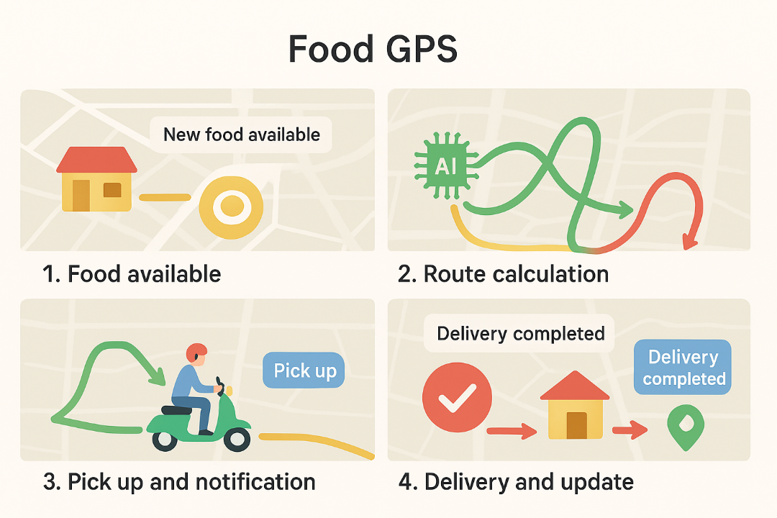
Finally, a combined visual storyboard was created to summarize the logic, experience, and feedback loop of the “Food GPS.” The final phase focuses on presenting the “Food GPS” solution clearly and persuasively. Using the prototypes developed in the Experimentation and Elaboration Phases, this stage highlights the problem context: visualizing food waste and insecurity to frame the need for a redistribution system; the solution journey: illustrating how surplus food moves from origin to recipient, guided by the AI and volunteers, using the storyboard and integrated visualization; the impact: emphasizing expected benefits such as waste reduction, improved access to food, and more efficient volunteer coordination; the visual Strategy: color-coded routes, simple icons, arrows, and minimal text ensure the audience quickly grasps the logic and flow of the system.

